Date: 29-11-2025 - 02-12-2025
Roll No: CB.EN.U4CCE23062

Scripting

Scripting can be of two types
- Client Side
- Server Side

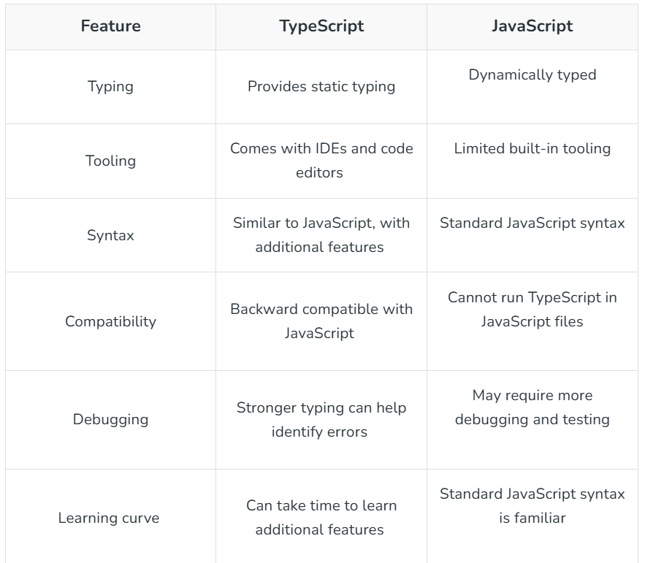

Check the difference between GET & POST

Control Name | Purpose | Validation/Custom Validation

Statements
Statements can be simple and compound, simple is nothing but a single line statement. Compound statements are muli – line statements

Design a form with two variables a and b and check the greatest of the two numbers and similarly compare and get the greatest with three number inputs too.
<!DOCTYPE html>
<html>
<head>
<title>Greatest of Two Numbers</title>
</head>
<body>
<h2>Find the Greatest of Two Numbers</h2>

<form onsubmit="findGreatest(event)">
<label for="a">Enter first number (a): </label>
<input type="number" id="a" name="a" required><br><br>

<label for="b">Enter second number (b): </label>
<input type="number" id="b" name="b" required><br><br>

<button type="submit">Check Greatest</button>
</form>

<h3 id="result"></h3>

<script>
function findGreatest(event) {
event.preventDefault(); // Prevent form submission

let a = parseFloat(document.getElementById("a").value);
let b = parseFloat(document.getElementById("b").value);
let result = "";

if (a > b) {
result = "a (" + a + ") is greater than b (" + b + ")";
} else if (b > a) {
result = "b (" + b + ") is greater than a (" + a + ")";
} else {
result = "Both numbers are equal.";
}

document.getElementById("result").textContent = result;
}
</script>
</body>
</html>

Three Number
<!DOCTYPE html>
<html>
<head>
<title>Greatest of Three Numbers</title>
</head>
<body>
<h2>Find the Greatest of Three Numbers</h2>

<form onsubmit="findGreatest(event)">
<label for="a">Enter number a: </label>
<input type="number" id="a" required><br><br>

<label for="b">Enter number b: </label>
<input type="number" id="b" required><br><br>

<label for="c">Enter number c: </label>
<input type="number" id="c" required><br><br>

<button type="submit">Check Greatest</button>
</form>

<h3 id="result"></h3>

<script>
function findGreatest(event) {
event.preventDefault();

let a = parseFloat(document.getElementById("a").value);
let b = parseFloat(document.getElementById("b").value);
let c = parseFloat(document.getElementById("c").value);

let greatest;

if (a >= b && a >= c) {
greatest = "a (" + a + ") is the greatest";
} else if (b >= a && b >= c) {
greatest = "b (" + b + ") is the greatest";
} else {
greatest = "c (" + c + ") is the greatest";
}

document.getElementById("result").textContent = greatest;
}
</script>
</body>
</html>

Calculator Program
<!DOCTYPE html>
<html>

<head>
<script src=
"https://cdnjs.cloudflare.com/ajax/libs/mathjs/10.6.4/math.js"
integrity=
"sha512-BbVEDjbqdN3Eow8+empLMrJlxXRj5nEitiCAK5A1pUr66+jLVejo3PmjIaucRnjlB0P9R3rBUs3g5jXc8ti+fQ=="
crossorigin="anonymous"
referrerpolicy="no-referrer"></script>
<script src=
"https://cdnjs.cloudflare.com/ajax/libs/mathjs/10.6.4/math.min.js"
integrity=
"sha512-iphNRh6dPbeuPGIrQbCdbBF/qcqadKWLa35YPVfMZMHBSI6PLJh1om2xCTWhpVpmUyb4IvVS9iYnnYMkleVXLA=="
crossorigin="anonymous"
referrerpolicy="no-referrer"></script>
<!-- for styling -->
<style>
table {
border: 1px solid black;
margin-left: auto;
margin-right: auto;
}

input[type="button"] {
width: 100%;
padding: 20px 40px;
background-color: green;
color: white;
font-size: 24px;
font-weight: bold;
border: none;
border-radius: 5px;
}

input[type="text"] {
padding: 20px 30px;
font-size: 24px;
font-weight: bold;
border: none;
border-radius: 5px;
border: 2px solid black;
}
</style>
</head>
<!-- create table -->

<body>
<table id="calcu">
<tr>
<td colspan="3"><input type="text" id="result"></td>
<!-- clr() function will call clr to clear all value -->
<td><input type="button" value="c" onclick="clr()" /> </td>
</tr>
<tr>
<!-- create button and assign value to each button -->
<!-- dis("1") will call function dis to display value -->
<td><input type="button" value="1" onclick="dis('1')"
onkeydown="myFunction(event)"> </td>
<td><input type="button" value="2" onclick="dis('2')"
onkeydown="myFunction(event)"> </td>
<td><input type="button" value="3" onclick="dis('3')"
onkeydown="myFunction(event)"> </td>
<td><input type="button" value="/" onclick="dis('/')"
onkeydown="myFunction(event)"> </td>
</tr>
<tr>
<td><input type="button" value="4" onclick="dis('4')"
onkeydown="myFunction(event)"> </td>
<td><input type="button" value="5" onclick="dis('5')"
onkeydown="myFunction(event)"> </td>
<td><input type="button" value="6" onclick="dis('6')"
onkeydown="myFunction(event)"> </td>
<td><input type="button" value="*" onclick="dis('*')"
onkeydown="myFunction(event)"> </td>
</tr>
<tr>
<td><input type="button" value="7" onclick="dis('7')"
onkeydown="myFunction(event)"> </td>
<td><input type="button" value="8" onclick="dis('8')"
onkeydown="myFunction(event)"> </td>
<td><input type="button" value="9" onclick="dis('9')"
onkeydown="myFunction(event)"> </td>
<td><input type="button" value="-" onclick="dis('-')"
onkeydown="myFunction(event)"> </td>
</tr>
<tr>
<td><input type="button" value="0" onclick="dis('0')"
onkeydown="myFunction(event)"> </td>
<td><input type="button" value="." onclick="dis('.')"
onkeydown="myFunction(event)"> </td>
<!-- solve function call function solve to evaluate value -->
<td><input type="button" value="=" onclick="solve()"> </td>

<td><input type="button" value="+" onclick="dis('+')"
onkeydown="myFunction(event)"> </td>
</tr>
</table>

<script>
// Function that display value
function dis(val) {
document.getElementById("result").value += val
}

function myFunction(event) {
if (event.key == '0' || event.key == '1'
|| event.key == '2' || event.key == '3'
|| event.key == '4' || event.key == '5'
|| event.key == '6' || event.key == '7'
|| event.key == '8' || event.key == '9'
|| event.key == '+' || event.key == '-'
|| event.key == '*' || event.key == '/')
document.getElementById("result").value += event.key;
}

let cal = document.getElementById("calcu");
cal.onkeyup = function (event) {
if (event.keyCode === 13) {
console.log("Enter");
let x = document.getElementById("result").value
console.log(x);
solve();
}
}

// Function that evaluates the digit and return result
function solve() {
let x = document.getElementById("result").value
let y = math.evaluate(x)
document.getElementById("result").value = y
}

// Function that clear the display
function clr() {
document.getElementById("result").value = ""
}
</script>
</body>
</html>

- For Loops:
The for loop repeats a block of code a specific number of times. It contains initialization, condition, and increment/decrement in one line.
// for loop begins when x=2
// and runs till x <= 4
for (let x = 2; x <= 4; x++) {
console.log("Value of x:" + x);
}

- For in loop
The for-in loop iterates over the enumerable keys of an object. Specially works with objects

const person = { name: "Alice", age: 22, city: "Delhi" };

for (let key in person) {
console.log(key, ":", person[key]);
}

- For each statement
The forEach loop executes a provided function once for each element in an array.
const numbers = [10, 20, 30];

numbers.forEach(function(num) {
console.log(num);
});

- While loop
let i = 0;
while (i < 3) {
console.log("Number:", i);
i++;
}

